

LUKENYA UNIVERSITY

FACTORS CONTRIBUTING TO PRIMARY-SECONDARY SCHOOL TRANSITION IN ISINYA SUB COUNTY IN KAGIADO COUNTY IN KENYA

BY
CYRUS SALAASH KOSENCHA
MED/02/0278-SBA/2019

A Research Project Submitted To The Faculty Of Education And Social Sciences In Partial Fulfilment Of The Requirements For The Award Of The Degree Of Master Of Education In Educational Administration, Lukenya University

DECLARATION
I declare that this research thesis is my original work and has not been presented for any award in any other college or University.
Cyrus S. Kosencha
Signature: _________________ Date: ______________________

This research thesis has been submitted for examination with our approval as the University supervisors.
Professor Imteyaz Ahmad-PhD
Signature………………………… Date ………………………………
School of Education and social sciences, Lukenya University

Dr. Samuel Ongoncho
School of Education and Social Sciences, Lukenya University
Signature……………………………. Date…………………….

COPYRIGHT
All rights are reserved. No part of this publication may reproduced ,stored in any retrieval system or in any form or by any means ,electronic, photocopying , recording or otherwise , without the prior permission of the author or the authority of Lukenya University(LU).

DEDICATION
I am dedicating this piece of work to my family: my wife Elizabeth, children: Edwin Moipei and Treasure Namunyak, mum Hanna, my late dad Samson Donkol, Brothers: Antony, Sam and Erick Kosencha, Sisters Frida and Janet Donkol for their prayer and financial support during this project.

Name of ur supervisors

Acknowledgement
The Almighty God for the strength and right mind to that unable me to undertake this research proposal .To my friend and mentor Dr. Jackson Ole Shukuru for his timely and professional guidance and support in writing this proposal. Supervisors, Dr. Samuel Ongoncho and Prof. Ahmed Imteyaz. For their guidance and support during this work. Thank you.

ABSTRACT
This research paper presents findings of a study on the factors influencing low transition rates of pupils from primary schools in Isinya sub county, Kagiado County. The study was guided by the following objectives: To determine the extent to which provision of teaching and learning resources influence the transition rate from primary schools to secondary schools in Isinya sub county. To determine the extent to which family socio-economic status influences the transition rate from primary schools to secondary schools in Isinya Sub County. To examine the extent to which distance from and to school influences the transition rate from primary schools to secondary schools in Isinya Sub County. To investigate the extent to which cultural practices influences the transition rates from primary to secondary schools in Isinya sub county, Kagiado County. There was also no evidence of researchers who had carried out a similar study in Isinya Sub County, Kagiado County. The study employed a mixed methods approach research design since the target population consisted of all the 30 secondary schools principals,42 head teachers of the public primary schools,1243 form one students in Isinya sub county. A total sample of 173 respondents were engaged from the sample drawn. These included 28 (19m; 9f) secondary school principals, 39 (24m; 15f) head teachers and 106 (77m; 29f) learners. Stratified random sampling method was used to pick the respondents. Questionnaires and personal interviews were the major tools for data collection. Research findings are based on research questions. From the findings there was a notable gap on the availability of teaching and learning Materials in the schools under study. Poverty was also noted to be a great influence on non-transition among many learners whilst parents and guardians interest on the education and academic performance of their children was noted to be wanting.

TABLE OF CONTENTS

  - Title Page (maximum of 20 words)--------------------------------------Not numbered
  - Declaration ---------------------------------------------------------------------------------(i)
  - Statement of Copy right ------------------------------------------------------------------(ii)
  - Dedication ---------------------------------------------------------------------------------iii)
  - Acknowledgment-------------------------------------------------------------------------(iv)
  - Abstract-------------------------------------------------------------------------------------(v)
  - Table of Content--------------------------------------------------------------------------(vi)
  - List of tables-(if Any)--------------------------------------------------------------------(vi)
  - List of figures(if any)-------------------------------------------------------------------(vii)
  - List of abbreviation--------------------------------------------------------------------(viii)
  - Definition of the Key Terms------------------------------------------------------------(ix)

CHAPTER ONE
INTRODUCTION
I.0 Introduction
1.1 Background of Study
1.2 Statement of Problems
1.3 Research Objectives
1.3.1 General Objectives
1.3.2 Specific Objectives
1.4 Research Question
1.5 Significance of Study
1.6 Scope of the Study
1.7 Limitation of the Study
1.8 Conceptual Frame Work

CHAPTER TWO
LITERATURE REVIEW
2.0 Introduction
2.1 Theoretical Literature
2.1.1
2.1.2
2.2 Empirical Literature
2.2.1
2.2.2
2.2.3
2.3 Relationship of The Literature to The Study
2.4 Gap in Literature /Research Gap

CHAPTER THREE
RESEARCH METHODOLOGY
3.0 Introduction
3.1 Research Approach
3.2 Research Design
3.3 Sampling
3.3.1 Population
3.3.2 Study Area(s)
3.3.3 Sampling Procedures
3.3.4 Sample Size -for Quantitative Data or Representativeness of Information for Qualitative Data.
3.4 Research Methods
3.4.1 Quantitative /Qualitative Methods
3.4.2 Piloting
3.4.3 Data Validity and Reliability of the Research
3.5 Data Collection Procedure
3.6 Qualitative /Quantitative Data Recording and Analysis
3.7 Ethical Implications
CHAPTER FOUR
DATA PRESENTATION, ANALYSIS AND DISCUSSION
4.0 Introduction
4.1 Background Information of Respondents
4.2 Discussion to the topic Concern
4.2.1
4.2.2
4.2.3
4.3 Evaluation of the Data Collected from various sources
4.3.1
4.3.2
4.3.3
4.3.4
4.4 Problems during the analytical process
4.4.1
4.4.2
4.4.3
4.4.4
4.5 Suggestion and Remarks by the Stake holder /institution/Head of institutions Etc.
4.6 Chapter Summary

CHAPTER FIVE
SUMMARY, CONCLUSION AND RECOMMENDATION
5.0 Introduction
5.1 Summary of the study
5.2 The Main findings of the Study
5.3 Conclusion
5.4 Recommendation
5.4.1 Recommendation for Improvement
5.4.2 Recommendation for further Research

TABLE OF CONTENTS

Recheck
FACTORS CONTRIBUTING TO LOW TRANSITION RATE FROM PRIMARY TO SECONDARY SCHOOLS IN ISINYA SUB COUNTY, KAJIADO COUNTY. 0
ABBREVIATIONS AND ACRONYMS 9
1.2 Statement of the problem 16
1.3 Purpose of the study 16
1.4 Objectives of the study 16
1.5 Research Questions 17
1.6 The significance of the study. 17
1.7 The limitations of the study 18
1.8 Delimitations of the study 18
1.9 Assumptions of the study 19
1.10 Organizational of the study 19
2.0 Introduction 20
2.1 Empirical literature. 20
2.1.1 Teaching and learning resources and transition rates. 20
2.1.2 Students’ family social-economic status and transition rates. 23
2.1.3 Distance from and to school and the transition rate. 24
2.1.4 Cultural practices and the transition rates. 24
2.2 Theoretical Framework 29
2.3 Conceptual framework 32
FACTORS CONTRIBUTING TO LOW TRANSITION LOW TRANSITION RATE 33
2.4 SUMMARY OF LITERATURE REVIEW
3.0 Introduction 34
3.1 Study Design 34
3.2 Target Population. 35
3.3 Sample Size and sampling procedures. 35
3.4 Research instruments. 36
3.4.1 Questionnaires 37
3.4.2 Interview Guides 37
3.4.1 Pilot testing 37
3.4.2 Instrument Validity 38
3.6.3 Instrument Reliability 38
3.5 Data Collection Procedures 38
3.6 Data Analysis Techniques 39
3.7 Logistical and Ethical Considerations 40
4.0 Introduction 42
4.1 Social Demographic Characteristics of Teachers 43
4.1.1 Social Demographic Characteristics of Learners 43
4.2 Availability of teaching and learning materials. 44
4.2.1 Institution provision of learning materials. 45
4.2.2 Cost of learning materials. 46
4.2.3 Cost of acquiring materials for learners 47
4.3 Effect of Parents finances on school Access 48
4.4 Parents’ interest in their children’s learning 49
4.5 Influence of School distance on Transition 49
4.5 Factors affecting learning and Transition 51
4.6 Mode of earning and effect on Education 51
4.7 Parents ability to pay school fees 53
4.8 Culture and Effect on Learning 53
4.9 Use of peer role models 54
5.0 Introduction 56
5.1 Summary of Findings 56
5.2Conclusion 59
5.3 Recommendations 59
5.4 Suggestions for Further Research 61
APPENDICES 62
QUESTIONNAIRE QUESTION FORM 64
REFERENCES. 80

ABBREVIATIONS AND ACRONYMS

FGM- Female Genital Mutilation
GOK- Government of Kenya
EFA- Education for all
M.G.DS - Malawi Growth Development Strategy.
M.O.E - Ministry of education.
NASET-National Alliance for Secondary Education and Transition
TSC - Teachers service commission.
UNESCO-United Nations Educational and Socio Cultural Organization
USAIDS- United States agency for International Development
EFA- Education for ALL
KCPE- Kenya Certificate of Primary Education
KCSE- Kenya Certificate of Secondary Education
KDHS- Kenya Demographic and Health Survey
KEC- Kenya Education Commission
KESS- Kenya Educational Sector Support Program.
MDGs -Millennium Development Goals
MOE - Ministry of Education.
MOEST - Ministry of Education Science and Technology.
UDHR - Universal Declaration of Human Rights.
UN- United Nations

OPERATIONAL DEFINATION OF TERMS
In this section, operational definitions of terms are presented as used within the context of this study.
Dropout - Refers to ceasing to attend school before completing the school cycle.
Efficiency- Refers to relationship between inputs and outputs into a system.
Secondary education- Refers to the single secondary stage of post-primary education.
Free secondary education- Refers to secondary education funded through taxation or charitable organizations rather than tuition fees. In Kenya it caters for tuition, repairs and maintenance, local transport, administration costs, electricity, water and conservancy, activity fees and personal emolument.
Human capital- Refers to stock of competencies, knowledge, social and personality attributes, including creativity, embodied in the ability to perform labor so as to produce economic value.
Physical facilities- Refers to classrooms, laboratories, playgrounds, desks, chairs
Teacher-pupil ratio- Refers to the number of pupils in a school divided by the number of teachers in the school.
Teaching resources- Refers to things/processes such as chalk, dusters, charts, field excursions, resource persons, experiments, geometrical sets, meter rules, plasticize, thumb pins, soft boards, felt pens pencils, and manila papers.
Wastage- Refers to the number of the students who either repeat a grade or drop out of school in a given period.
Transition – This is the advancement of pupils from one level of education to another. It means that the students who enrolled to school in standard one are able to go through the 12 year course of both primary and secondary education. The students are able to graduate or proceed to the next stage or class

CHAPTER ONE
INTRODUCTION

- INTRODUCTION
This study sets out to analyze factors that could affect a student transition from primary school to secondary school which may lower his/ her chances of ever being in a university or a tertiary collage in Isinya sub county, Kagiado County.
1.1 Background of the study.
Education is a fundamental human right because it empowers individuals with the knowledge and skills needed to increase production and income, as well as enabling individuals take advantage of employment opportunities in order to reduce poverty (UNESCO, 2010). It is the valuable thing that society can bequeath its membership. It helps fight ignorance and the acquisition of knowledge creating a better citizenry in terms of prospects in life (Fanuel, 2011). Under the education for all (EFA) program driven by UNESCO, many Countries have committed to having universal environment in primary education by the year 2015 and this has made it compulsory for children to receive primary education in many countries, (Karlusky, 2010).
Globally, measures to improve education have been put in place to improve the standards and quality in educational outcomes (Kenny C, 2010). According to World Bank (2015), many countries over the world have embraced the notion of basic education to include secondary schooling that is significant of individual’s future life. The transitional toolkits like the National Alliance for Secondary Education and Transition (NASET, 2015) articulate guide on secondary education for constructive change on transition practices and policies worldwide. Secondary schooling is a bridge between primary and university education that caters for students of age brackets of between 15-18 years. It plays important role in creating the country human resource based at a higher level than primary education.
According to World Bank 2001 in California, teaching and learning materials were crucial ingredients in learning and the intended curriculum could not be easily implemented without them. It was universally acknowledged that textbooks and instrumental materials were fundamental and essential because they are the primary tools that schools used to provide students with knowledge and skills expected to learn (USAIDS, 2002). Hence they contributed to students’ academic achievements which determine the transition rates of pupils from primary schools to secondary schools.
In Malawi the transition rate was very low as only 16 percent of children transitioned from primary to secondary and only 8 percent got to tertiary level (Malawi Growth Development Strategy -MGDS III).The transition rate is particularly far much lower for the girl child because girls lack sanitary materials and psychosocial support to encourage continuity of education. The girls have erratic school attendance and majority drop out of school as many are loss to property such as school uniform, writing materials and text books and are exposed to various vulnerabilities including gender based violence, sexual abuse and harassment. The inequalities and early child marriages and unplanned pregnancies as well as exposure to high risky diseases such as HIV and Aids are hindrances to a girl child’s education.
In Uganda schools are overcrowded, resulting in a high drop-out rate. At the same time, 25% of primary school children and 86% of secondary school students remain out-of-school this is due to the large Refugees population who also need protection and services which includes financial and social assistance and psychosocial support for unaccompanied minors, disabled people, trauma survivors and victims of gender-based violence. In Kenya, Secondary education examination marks the termination of the four years of secondary education in the Kenyan education system which basically used for selection into university and the tertiary training colleges (MOE, 2013). Secondary education is regarded to as the route to economic prosperity, the key to scientific and technological advancement, and the means to combat unemployment and foundation to social equality. Transition from secondary education into university education is of great importance since higher education institutions plays a crucial role of building capacity for generation, adaptation, processing, dissemination and utilization of knowledge and innovation into social and economic development (G.O.K, 2016). The transition of the students from primary school system to secondary school system then form the backbone of an individual student to the said benefits of education system to the individual, family and to the society in general.
In Isinya Sub County predominantly occupied by the Maasai people has a various challenges. Some of the challenges the researcher seek to find out are vast distance between schools of about 30 kilometers apart, cultural practices that affect the education system, low teacher-leaner ration especially in rural schools, prevalence of high levels of poverty which affect the education of the learners hence affect the transition to various levels of education.

1.2 Statement of the problem
In the ideal situation the learners should be able to perform well since they have been undertaken through the curriculum requirement of eight years by their teachers.
If the problem is not addressed through provision of teaching and learning materials which at the moment are inadequate, the situation may deteriorate further increasing the levels of illiteracy and high levels of dependency and hence high levels of poverty.
There is very little evidence of research done to analyses low transition rates from primary schools to secondary schools in Isinya sub county, Kagiado County bearing in mind the social and cultural way of life of the indigenous community, the Maasai people. The study provides an analysis of the reasons behind the low transition rates from primary schools to secondary schools in Isinya sub county, Kagiado County.

1.3 Purpose of the study
The purpose of this study was to determine the factors contributing low transition rates from primary schools to secondary schools in Isinya Sub County, Kagiado County.

1.3 Research Objectives

1.3.1 General Objective
The general objective of this study was to determine the factors contributing primary-secondary school transition in Isinya Sub County in Kagiado County, Kenya.

1.3.2 Specific Objectives
The study was guided by the following specific objectives
1. To find out the extent to which provision of teaching and learning resources influence the transition rate from primary schools to secondary schools in Isinya Sub County, Kagiado County.
2. To determine the extent to which distance from and to school affects the transition rate from primary schools to secondary schools in Isinya Sub County, Kajiado County.
3. To establish the extent to which family socio-economic status influence the transition rate from primary schools to secondary schools in Isinya Sub County, Kajiado County.
4. To determine the extent to which cultural practices influences the transition rates from primary to secondary schools in Isinya sub county, Kajiado County.

1.5 Research Questions
The research exercise was guided by the following questions: -
1. To what extend does provision of teaching and learning resources influence the transition rate from primary schools to Secondary Schools Isinya Sub County?
2. How does distance covered from and to school influences the transition rate from primary schools to secondary schools in Isinya Sub County?
3. How does family socio-economic status influence the transition rate from primary schools to secondary schools in Isinya Sub County?
4. How do cultural practices influence the transition rates from primary to secondary schools in Isinya Sub County?

1.6 The significance of the study.
Findings of this study are significant to the teachers who will use the data to determine why there is low transition rate from primary to secondary schools. The study is also useful to both county and national governments to review policies on learners transition rates. Future researchers will find this study critical in advancing their research.

1.7 The limitations of the study
Factors that provided some limitations to this study included following:
Language: Some of the participants in the study were not very familiar to the terminologies used in the study. Among these were some of the headteachers and principals who had served for over 15 years. This made administration of the questionnaires difficult and time consuming. The researcher thus employed educated research assistant conversant with the local language to assist in overcoming this challenge.
Vastness of the area of study: The protracted area of study is vast and schools are far apart to a tune of 30 kilometers apart. This required time and money to undertake this study. The researcher used bodaboda as the most convenient means of transport to reach the vast areas.
Time limitation - Due to the time constraint, it was not possible to collect information exhaustively.

1.8 Delimitations of the study
Observation to the current pandemic covid-19, the rules by the ministry of education on safety and protection of the respondents and all the people involved in the process of data collection were observed. The researcher kept the questions short and easy to understand to avoid ambiguity. The researcher developed good rapport with the respondents during the process.

1.9 Assumptions of the study
The study had made the following assumptions;
- That the learners transiting from primary schools to secondary schools were of ages of between 15-18 years.
- That the learners complete the syllabus in time for preparation for the final examinations.
- That each and every learner was provided with the resources required for syllabus completion.

1.10 Organizational of the study
The study has been organized into five chapters as follows. Chapter one consist of the background of the study, statement of the problem, objectives of the study, research questions, significance of the study, limitations and delimitations of the study, assumptions of the study, the organization of the study and the scope of the study. Chapter includes literature review, drawing references, views and comments from authorities on the subject under study while the third chapter illustrates the methodology used in the study. Chapter 4 is presentation of the study findings while chapter 5 draws a summary of the fundings and provides a conclusion while making key recommendations on how the identified gaps could be improved on.

CHAPTER TWO
LITERATURE REVIEW

2.0 Introduction
In this chapter the researcher will present the empirical literature, theoretical literature, conceptual framework and a summary of literature related to the study. The section covers the teaching and learning resources, the student’s family socio-economic status, the distance from and to school and the cultural practices.

2.1 Empirical literature.
The empirical literature of the study will be done in order to extend the researchers knowledge on the factors that contribute to low transition rates from primary to secondary schools in Isinya sub county, Kagiado county.

2.1.1 Teaching and learning resources and transition rates.
School based factors such as school rules, attitudes, the curriculum, teachers, physical facilities, and management practices does affect students transition rates (Kariuki, 1976). The management of material resources entails planning, acquisition, allocation, distribution and controlling the use and maintenance of the materials. Onyango (2001) states that planning for material resources involved the identification of the resource requirements, assessing quality in terms of the needs, establishing criteria for standards, determining the cost per unit and the use of the materials whether by individuals or groups. The availability and use of teaching and learning materials affects the effectiveness of teachers’ lessons. Avalos (1991) suggested that the quality of education the learner received bears direct relevance to the availability or lack of instruction materials. All individual have the right to a quality educational facility, a physical space that supports a multiple and diverse teaching and learning programs and pedagogies.
According to Ngugi (2006), learning resources can improve transitional rates from secondary to University because they are tools that enhance literacy, mathematics and science. Availability and the use of learning resources by teachers and students were evidenced by better learning. Without teaching and learning resources the learning process becomes rigid, rely heavily on rote learning which places learners on a passive role. Learning resources avail structural teachings which are a combination of directly instruction, guided practice and independence learning which create a child-friendly school environment.
USAID (2002) announced the reconstruction of Afghanistan by providing 1.7 million, science, mathematics and reading materials for Afghanistan students in grade 1 to twelve. The first lady Laura Bush noted that nothing more important for Afghanistan future than giving its children’s the tools and skills they need to learn and succeed. (OECD) stipulates textbooks as an important international indicator for educational quality, therefore to achieve the goal of Universal declaration on education for all basic learning materials should be made available for teachers and students (UNESCO 2006).
According to the Global Monitoring Report on Education for All (1987), students’ access to teaching and learning was an important factor in what and how much they learned (UNESCO 2008) carried out a study that established that the availability of learning resources had an effect on quality education in Botswana. The study revealed that teaching/learning resources had a direct link to the education quality measured in terms of students’ performance that determines transition rates from one level of education to the other. Education supplies should respond to the country’s culture and local practices in education while encouraging the participation and active learning of students.
Obonyo (1987) noted that instructional materials such as textbooks, visual and audio materials not only enhanced communication between the teacher and the learner but also facilitated child centered learning and learning through discovery. They motivated and encouraged participation by learner in the learning process and helped to clarify concepts and add meaning to texts. However, schools that parents pay school fees for the provision of learning resources are likely to register better performance leading to high transition of learners to through educational levels
According to secondary education strategy report 2007-2010 performance level of a school was mostly determined by availability of teaching and learning resources. Low transition of students from secondary to university can be attributed to inequity in the distribution of learning resources. For instance, national secondary schools are fully maintained by the government, extra county schools are partially maintained by government and partially by the parents and county schools are started through community initiatives or harambee spirit these has then seen difference in the transition from the categories of school.

2.1.2 Students’ family social-economic status and transition rates.
The socio-economic factors such as parent’s education level, parent’s occupation, family size, birth order, gender, occupational aspirations, parental involvement or students own attitudes towards education also have an effect on transition rates (Kariuki, 1976). Family socio-economic status affects children’s education. School variables account for only a modest proportion of teachers match the strength of students Governments in Sub-Saharan African countries are concerned that if the secondary education continues to charge fees, the majority of those who complete Free Primary Education will be unable to continue to secondary education. In many cases these are children from poor households whose parents are unable to afford the cost of secondary education, making the children dwell in the vicious cycle of poverty (UNESCO, 2003).
GOK (2006), states that in Kenya, it has been observed that access to higher education benefits the rich more than the poor. This is manifested through the way in which the increasing competition for transit to university and tertiary education. These trends excludes students from low income families who will not afford the emerging of the self-sponsored programs for university education, which caters for the students who can afford to pay the prevailing market fees charged by the universities. Due to inadequate opportunities for government sponsorship in universities, many Kenyans are forced to shoulder their responsibility of financing the higher education of their children, a burden that is proving to be too heavy for most households. Therefore students from poor families are left out in the acquisition of better professions like engineering and medicine that are dominated by the students from able families who can afford to pay for quality education as early from pre-school.

2.1.3 Distance from and to school and the transition rate.
Long distance has opposing results among researchers on academic performance. It is commonly argued that longer distance to school reduces the ability of learners to focus their attention in studies due to long walks or getting to class late. In some cases, because of traveling long distances without assured transport, students are trapped into unhealthy sexual behaviors which could not have been triggered if they walked reasonable distances to and from school. For example, it is common to hear girl students reported to be pregnant in most of the community schools because of living in a rented houses. Emore (2005) shares that distance to school together with school discipline; family background and school location caused truancy (attendance irregularity) among school students. Distance in association with location of the school seems to be one of the strong influencing origins for the academic performance among students. This was evidenced as well by Obemeata (1995) and Obayan (2003) who confirmed that school physical environment exerts dominant influence on students’ academic performance. To improve schools and students‘ academic performance, parents or community members in collaboration with the local authority leaders should not be driven by their personal motives when locating schools. Educational authorities should develop, distribute and strictly administer standards to guide all providers (public and private) adhere to the laid standards.

2.1.4 Cultural practices and the transition rates.
The cultures of the Maasai people who are the indigenous people and majority occupants of Isinya Sub County have the following characteristics that affect their way of life.

a) The Maasai people way of life.
The Maasai people are a semi-nomadic Nilotic ethnic group. Because pastoralism is their way of life, the Maasai live mainly in the grasslands of the Great Rift Valley. They have been nomadic for quite a long time but are now semi-nomadic due to modernization coupled with foreign land tenure systems. The language of the Maasai people is known as Maa.
The community’s way of life has been changing with time due to lose of land. Large tracks of land have been excised off by the Government as National parks and game reserves. This excision denies them grazing rights in these areas and they have thus been forced to adopt a sedentary lifestyle. The community is not afraid of living side by side with wild life even the fiercest among them like lions and cheetahs. The Maasai do not kill wild animals for meat perhaps because they have enough livestock for meat supply. The community places a great premium on their old age tradition of having warriors – who were the army. The young people between the ages of 20 and 30 years protect the community from external attacks.The Maasai are also known for the famous traditional dance that involves swinging the neck plus jumping in some uniform motion in one spot. Only men danced and jumped in this characteristic manner. The women sang by swinging their necks clad with all sorts of ornaments / necklaces.
People of the Maasai tribe live in small settlements of approximately 10-20 huts per village. A number of households constitute a Manyatta (Kituyi Mukhisa 1990). The kraal (a traditional homestead or group of huts) is surrounded by a thorn bush fence, which acted as the barbed wire, guarding the people and their animals against enemies. Women are the architects and builders of these traditional houses and it was indeed a taboo for a man to be found performing that role. The huts are built using branches, twigs and grass with a cement of cow dung made soft using cows’ urine. The mixture is as strong as cement after it gets dried in the sun and does not smell. In the inside animal skins and cushions of dry grasses are used for beddings. The family sleeps on these beds of woven branches cushioned with dry grass and animals’ skins. People particularly adults cannot stand straight up while inside of the hut due to its height. The only openings that there are in the hut include the doorway and a small opening made either in the roof or wall which allows smoke from a continually blazing fire inside to escape. Dried cow dung is used to fuel the fire.
Their rites of passage and traditional ceremonies are well defined and taken very seriously. Elders play a very important role in the community when it comes to these rites and they were highly respected (Kituyi Mukhisa 1990). Some rites are meant to cleanse young people of their wrongdoing so that they do not move on to adulthood without sanctity. Children and/or young people who have gone through the various rites of passage are appointed to take others through the same. They are to act either as mentors or simply associate to help each other grow up in obedience to the requirements of the traditional laws.
The role of everyone is clearly defined. The women and girls primarily, it is their responsibility to milk the cows, fetch water and firewood, and prepare food for the family. For the boys, fifteen is the coming of age and several rituals are performed before they become circumcised and end up as Morans (young warriors). The Morans were traditionally allowed to invade other communities to ‘repossess’ the cows and this would not according to them amount to stealing.
Knowledge was passed from generation to generation orally. Nothing at all was written. Even today, very little has been documented. The transmission of knowledge was done through a number of ways including story telling especially by grandmothers. Boys and girls gathered at the grandma’s hut in the evening and stories would be narrated. The stories were systematic and each carried an important theme and lesson.
b) Leadership systems of the Maasai
The Maasai community is paternal meaning that most major decisions are made by and in favor of the man. Duties and responsibilities were clearly segregated. The elderly men managed the day-to-day affairs of the community. They gave direction on the way things are supposed to be. They were advisors whenever hard decisions were to be made and mediators in case there was conflict to be resolved. Some of the decisions they made involved issues of marriage for instance setting the bride price and determining course of action in case of a family relations dispute, deciding whether to advance to war against an aggressor, setting the age sets and age groups and determining where one should stop and/or the other begins, define what behavior is considered defiant and the remedy or corresponding punishment, setting standards of acceptable behavior for all members of society, setting precedence on emerging issues (equal to making new laws) and the like. At the family level, there was minimal consultation. The man directed and would announce whatever had to be done. At the community level the story is pretty much the same. Other people may be allowed to give their views but the ultimate decision rested with the elders. The women took care of children, cooked for the family, fetched water and fire wood, made and maintained the houses. The girls assisted women to perform their roles as the former get mentored to take up those roles in future. The warriors known for their famous name of morans served as the army protecting the community from all intrusions and attacks. The role of herding was primarily theirs and they shared this responsibility with the boys as they mentor them.
Selection of leaders among the Maasai people was a very important exercise. No one insinuated that they aspired to lead. There was no clamor for position in society. The others saw leadership qualities in a person and pushed or passed recommendations to have him as their leader. It was the prerogative of the elders to select the leaders into various positions and the criteria was very clear. History formed some important consideration in that one’s parents must have been good people. One also had to be hardworking, honest, generous, kind and peace loving. In this regard therefore not everyone qualified to be a leader. People understood that leadership came with a lot of responsibility to serve the others. Most often those appointed had to be persuaded and urged to accept the positions because of the burden that it entailed. Leadership involved coordination of community activities, assisting the poor, resolving conflicts and being involved in decision making in times of uncertainty. The leaders genuinely pursued goals that enhanced the general good of the subjects and they did not expect anything in return. The community was very superstitious and the functions of leadership could not be so separated from religious activities. This trend coupled with water tight systems to enforce honesty ensured that no leader was corrupt in any way. The leadership principles were enshrined in a set of oral traditional beliefs transmitted through myths, proverbs, sayings and other literature.

2.2 Theoretical Framework
This study will be guided by the functionalist theory brought about by a French sociologist Emile Durkheim {1858-1917} who is regarded as one of the fathers of academic discipline of sociology. The theory focuses on the ways that universal education serves the needs of society. Education is seen in its manifest role of conveying basic knowledge and skills to the next generation. Durkheim identified the important role of education as one of socializing agent that brings people into society's mainstream. This helped to form a more cohesive social structure by bringing together people from diverse backgrounds. Functionalists point to other latent roles of education such as transmission of core values and social control. The core values in education reflect those characteristics that support the political and economic systems that originally fueled education. Therefore, children will receive rewards for following schedules, following directions, meeting deadlines, and obeying authority (Miguel, 2003)
The most important value permeating the classroom is individualism—the ideology that advocates the liberty rights or independent action of the individual. Students learn early, that society seeks out and reveres the best individual, whether that person achieves the best score on a test or the most points on the basketball court. Even collaborative activities focus on the leader, and team sports single out the one most valuable player of the year. The carefully constructed curriculum helps students develop their identities and self-esteem. Conversely, in a culture that values community in place of individuality, learn to be ashamed if someone singles them out, and learn social esteem—how to bring honor to the group, rather than to themselves (Morrison, 1997).
Going to school in a capitalist nation, students also quickly learn the importance of competition, through both competitive learning games in the classroom, and through activities and athletics outside the classroom. Some kind of prize or reward usually motivates them to play, so students learn early to associate winning with possessing. Likewise, schools overtly teach patriotism, a preserver of political structure. Students must learn the stories of the nation's heroes and exploits.
Another benefit that functionalists see in education is sorting/separating students on the basis of merit. Society's needs demand that the most capable people get channeled into the most important occupations. Schools identify the most capable students early. This process is a beneficial function in the society. After sorting has taken place, the next function of education, networking (making interpersonal connections) is inevitable. Learners in high school and college network with those in similar classes and majors. This networking may become professional or remain personal. The most Significant role of education in this regard is matchmaking. Sociologists primarily interest themselves in how sorting and networking lead couples together of similar backgrounds, interests, education, and income potential. People place so much importance on this function of education that some parents limit their children's options for college to insure that they attend schools where they can meet the right person to marry.
Functionalists point to the ironic dual role of education in both preserving and changing culture. Studies show that, as students‘progress through college and beyond, they usually become increasingly liberal as they encounter a variety of perspectives. Thus, more educated individuals are generally more liberal, while less educated people tend toward conservatism. Moreover, the heavy emphasis on research at most institutions of higher education puts them on the cutting edge of changes in knowledge, and, in many cases, changes in values as well. Therefore, while the primary role of education is to preserve and pass on knowledge and skills, education is also in the business of transforming them (Parsuramen, 1994).
Figure 1 Theoretical Framework

2.3 Conceptual framework
Conceptual framework is a diagrammatic representation of how different variables interrelate and interact to influence the dependent variables. It is assumed that these independent variables interact with each other and in turn bring about certain levels of achievement. From the studies and literature, various factors independently and or interdependently influence the rate of transition of the students from primary schools to secondary schools especially in arid and semi-arid areas. The conceptual framework of this study is based on the inter-relations between rate of transition from primary schools to secondary schools (dependent variables) and provision of teaching and learning materials, distance from and to school, family socio-economic status and cultural practices
Family Economic Status
- Parents’ Occupation
- Current Economic Situation

Primary-Secondary School Transition

- Number of pupils leaving primary school and joining secondary school
- Number of pupils and students dropper out of school

Family Cultural Practices
- Female Genital Mutilation
- Cultural ceremonies
- Nomadic lifestyle

- a.

Family Social Status
- Size of family
- Parents’ involvement in education matters
- Teenage pregnancies

Independent Variables Dependent Variable
Figure 2.1: Conceptual Framework

Independent Variables Dependent Variables
FACTORS CONTRIBUTING TO LOW TRANSITION LOW TRANSITION RATE
Teaching-learning resources
- Teachers-pupils ratio
- Reference materials
- Physical facilities

Distance to and from school
- Tiredness in class
- Attack from strangers\wild animals
- Teenage pregnancies

Primary-Secondary School Transition
- Number of pupils leaving primary school and joining secondary school
- Number of pupils and students dropper out of school

Family social-economic status
- Size of family
- Occupation of the parents
- Parents involvement in education matters

Cultural practices
- FGM
- Traditional ceremonies
- Nomadic lifestyle

Figure 2 Conceptual Framework
Source
Check it again

CHAPTER THREE
RESEARCH METHODOLOGY

3.0 Introduction
This chapter gives a detailed outline on the process that was applied to collect and analyze the data from the field.

3.1 Study Design
This study used the convergent and concurrent research model which is a design used for analyzing quantitative and qualitative data. A researcher uses the concurrent research design when the aim is to merge the quantitative and qualitative data to address the study objectives (Creswell, 2009). Qualitative research involves field work, which means that the researcher must go to the settings or institution to observe behavior, experiences and perspectives in their natural settings (Mirriam, 1998 cited in Buthelezi, 2014). Creswell (2009) further affirms that, in concurrent and convergent design, quantitative and qualitative data will be collected concurrently, analyzed separately and then merged. The researcher used the mixed research design to carry out this study. The mixed methods approach involved the use of both quantitative and qualitative approaches in data collection. This helped the researcher to understand better the perceptions of principals, head teachers, teachers and learners regarding transition rates.

3.2 Target Population.
The study involved all the 28 principals, 39 head teachers and 106 form one students.

3.3 Sample Size and sampling procedures.
The researcher opted for stratified sampling technique. The population was grouped into different sub-groups namely head teachers, principals, teachers and students. These four categories of people had different levels of involvement and play different roles in the running of the schools activities. A sample of 10% is sufficient for a study ( Mugenda and Mugenda 2013). Purposive sampling method was used in selecting principals and head teachers because choosing the respondents who are reliable could make the collected data have value and valid results (Tukur & Kiyuba, 2014).The simple random sampling method was used for the learners.

Table 1
CATEGORY OF POPULATION | TOTAL POPULATION | SAMPLED POPULATION | SAMPLING PROCEDURE
Principals | 30 | 3 | Purposive random
Form one students | 1223 | 122 | Simple random
Head teachers | 42 | 4 | Purposive random
SDE | 1 | 1
TOTAL 1316 130

3.4 Research instruments.
In this study, questionnaires and interview guides were administered to respondents as tools for data collection. The choice of this instrument over others was informed by its practicality and covid -19 protocols existing during the time of the study. The tools were strategic for they enabled the researcher to collect information from a large number of people over a relatively short period of time. Additionally the information was easily quantifiable by the researcher.

3.4.1 Questionnaires
The questionnaires had close-ended, structured and un-structured questions that were employed to elicit specific information from a list of possible alternatives, which the respondents were required to respond to. The questionnaires were constructed using open ended, unstructured questions, which required the respondents to construct responses to express their feelings and opinions. The questionnaire consisted of four sections. Section 1 which contained structured questions that aimed to collect personal information of the participants. The other three sections contained structured and unstructured questions that provided responses based on the objectives of the study. The questionnaires were self-administered in two ways.

3.4.2 Interview Guides
Through the use of interview guide, the researcher was able to enter the world of the sub county director and this helped the researcher to obtain an inside perceptions and his/her experiences (Buthelezi, 2014).

3.4.1 Pilot testing
A pilot study was conducted. The pilot study helped the researcher to review the research instruments so that the questions were focused on developing a deeper understanding of the situation studied (Udoba 2014). The pilot study was carried out in Isinya Sub Couny, Kajiado county before carrying out the study to test research instruments. The pilot study was done on 1 principal, 2 head teachers and 10 students. This was 10% of the sample according to Mugenda and Mugenda( 20013)

3.4.2 Instrument Validity
Best and Khan (2016) asserted that validity of an instrument refers to asking the right question formed in the least ambitious way. Validity is concerned with whether the results appear to be what they are. Orodho (2017) says that validity is concerned with establishing whether the tools content is measuring what is supposed to measure. Content validity is ensured through pilot testing. Content validity was achieved through the review of the relevant literature to find out the relevant concepts. External validity was achieved through generalization of the findings of the studies.

3.6.3 Instrument Reliability
Saunders et. Al. (2019) defined reliability as the extent to which your data collection analysis procedure will yield consistent findings. A reliable measureable is one which if it will be repeated for a second time it will give the same results as in the first case. For example a pupil who scores 90% in an examination will score similar marks in the same examination if it is administered the second time. Hairret. Al. (2016) said that Cronbach’s Alpha measures internal consistency of how closely related a set of items are as a group. Items should be closely related to be reliable. A measure of Cronbach Alpha of 0.7 and above means that there is reliability. A measure of 0.7 and below there is no reliability whereas a measure of 1.0 on Cronbach Alpha indicates a perfect reliability 100%.

3.5 Data Collection Procedures
After getting the introduction letter from Lukenya University, the researcher proceeded to apply for a research permit from National Commission for Science, Technology and Innovation (NACOSTI). The researcher then proceeded to the County Commissioners officer in Kajiado County and subsequently to sub county director of education (SDE) Isinya Sub County for authorization to visit schools. The researcher visited the schools and started by briefing the head teachers on the purpose of the visit. With permission granted by the head teacher, he proceeded to interview the head teachers and then did sampling of the teachers before administering the questionnaires. The researcher then collected the questionnaires immediately. This ensured a higher return rate.

3.6 Data Analysis Techniques
Data analysis is the process of organizing the collected data into categories (Kothari, 2008). Data analysis is important for interpreting raw data in order to obtain their meaning and pattern from data (Bell, 2005 cited in Udoba, 2014). The aim of data analysis is to transform information or data into an answer to the original research question. In this study, data analysis was done after completion of the process of data collection.
Quantitative data was analyzed using descriptive statistics namely: frequencies, percentages and mean. Quantitative data has been presented in tables, figures and charts. Qualitative data has been organized in themes and presented in narratives and direct quotations. A thematic analysis has been used to arrange, organize, break the data units, synthesize and search patterns to be learnt as brought out by the respondents. The researcher has categorized the data into themes according to research objectives and use the thematic analysis through discussion and presented it in form of narratives and direct quotations. According to Orodho (2009), qualitative data analysis will involve coding the data, dividing the text into smaller units (Phrases, sentences or paragraphs), assigning a label to each unit, and then regrouping the codes into themes. Qualitative data sought to understand the experiences and management practices that head teachers face and how to solve the management problems related to transition. The results from the observation schedules has been analyzed descriptively along thematic areas and used to provide supporting narratives to the study.

3.7 Logistical and Ethical Considerations
In order to avoid issues that may put the study into disrepute in any way, the researcher has been cautious to put in place all logistical and ethical considerations. The researcher sought letters of introduction to allow progress with relevant approvals. Plans were put in place to ensure that the research study went on as scheduled. The purpose of the study was made very clear in order to ensure that the information given is accurate and honest. Every data collected from the respondents was kept in anonymity for ethical considerations. The researcher employed the services of a research assistant in order for the targets of the research study to be realized in time. The researcher ensured that the assistant fully understood the objectives of the study and all necessary other requirements to make the exercise a success. The purpose of having a research assistant was mainlyfor distribution and collection of the questionnaires from the respondents. The researcher was careful to keep all the data gathered in the field in order to avoid situation in which he will have to reconstruct the information gotten from the field due to loss (Vyhmeister.2001). In this case, the researcher developed a system that was easy to manage the storage of information in consideration of logistical and ethical issues that relates to research.

CHAPTER FOUR
DATA ANALYSIS, RESULTS AND INTERPRETATION

4.0 Introduction
This section presents views of the participants who took up the study. It outlines their social demographic characteristics before giving a detailed report on their responses based on the study objectives and questions. The researcher has made some effort to discuss and compare their views, as appropriate. Findings based on responses from Secondary school principals, primary school head teachers and learners have been qualitatively analyzed with similar responses put together. Responses from the principals and the head teachers were quite similar with negligible difference. Views of learners on the study subject also tied with what the teachers pointed out o although they did not shed much on aspects related to management. The study incorporated a total 174 out of the expected 182 respondents being 29 (19m;9f) secondary school princilas,39 (24m;15f) primary school headteachers and 106 (77m;29 f) learners from secondary school.

4.1 Social Demographic Characteristics of Teachers
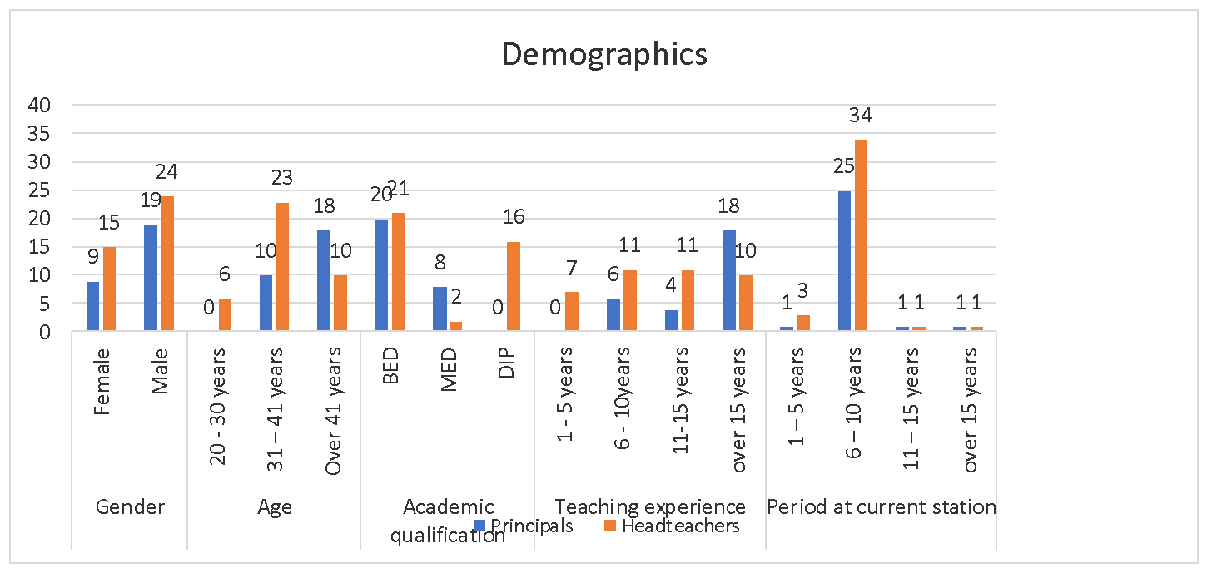Figure 3: Social Demographic Characteristics of Respondents
Source
A total of 28 (14f;14m) principals and 39(24f,15m)- headteachers took up the survey. Majority of the principals were above 41 years of age while headteachers in the age catergory31-40 were the most. There were 10 teachers with a Masters Degree qualification. Bachelor of Education was the most qualification for both the principals and the headteachers. All principals had over 5 years’ experience in teaching majority of whom have been in service for over 20 years. Most head teachers had served for 10 years, with a few serving between 1-5 years. The teachers have served for their current institutions for an average of 8 years.

4.1.1 Social Demographic Characteristics of Learners
A total of 106 learners were engaged in the study. They included 29female and 77male. Majority (93%) of them were 16 years.
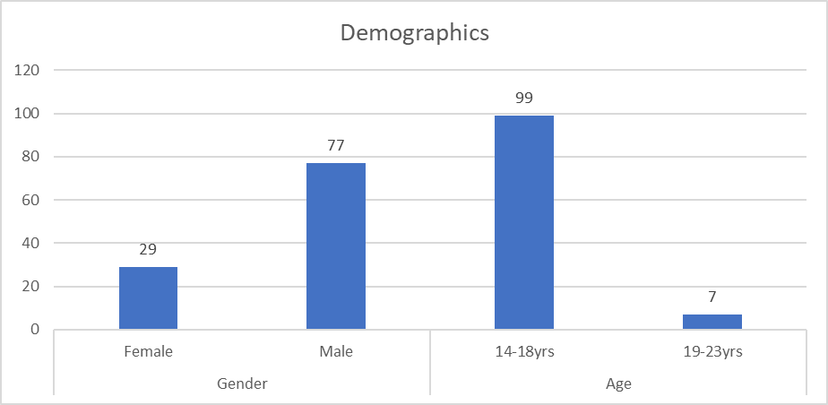
Figure 4: Social Demographic Characteristics of Learners
Source

4.2 Availability of teaching and learning materials.
Among the key factors investigated to be influencing transition was the status of teaching and learning materials in the schools under study. Asked which of the materials were being used in the schools the teachers noted an assortment including Chalk board/chalk, Course books White board/mark pen Supplementary books Charts and Pens. The findings further established that materials such as the whiteboard, charts, teachers guides, and reference books were unavailable despite being of equal necessity for teaching and learning. On further probing, the researcher noted that there was some preference for use of course books (government approved reference materials) by most of the teachers, as opposed to supplementary books.
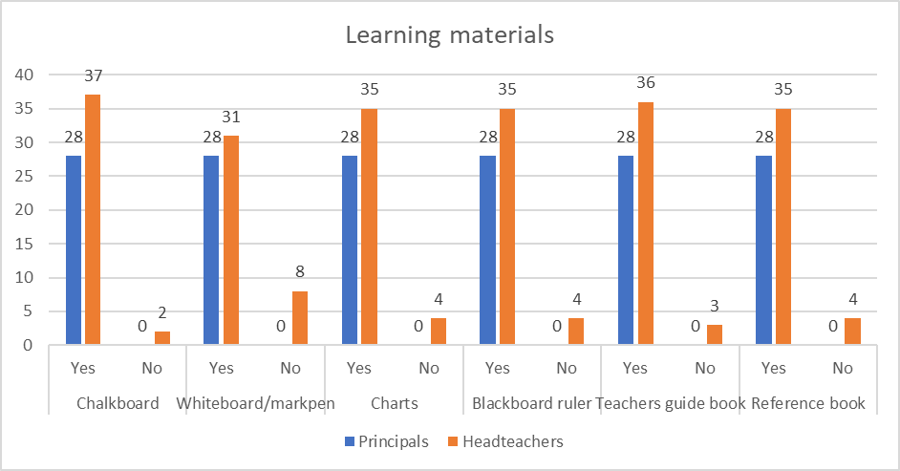
Figure 5: Learning materials available in school
Source

4.2.1 Institution provision of learning materials.
Having established the kinds of materials available in schools, the researcher went further to find out on whether the institutions make any efforts to avail such materials. Evidence from the study, as provided by the principals and headteachers noted glaring gaps in terms of the role of the institution in providing teaching and learning materials. As presented in figure 4 below, more than three quarters (22 out of 28 -79%) of the principals indicated that their institutions provide the materials. However comparing this finding to the head teachers, a different trend was noted at the with barely a third (11 out of 39-28%) of the headteachers acknowledging that their institutions do provide these materials. On further probing, the researcher learnt that inspite of the provision of school funds by government under the free primary education policy, the current attention has largely been on CBC than the 8-8-4 system making most public schools go without these essential materials..
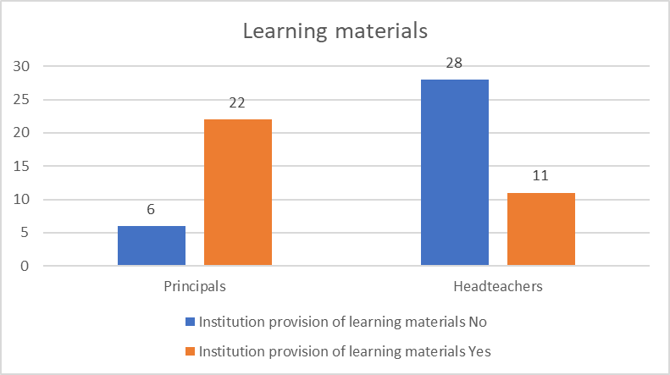
Figure 6: Institutional provision of learning materials
Source

4.2.2 Cost of learning materials.
The researcher further went on to find out on the cost of buying the materials. The general feeling was that the materials were essentially expensive with a majority of the respondents quoting their cost at between 5000-8000kes. Apparently, the principals seemed most affected, tying this to the fact that they may not be (fully) getting government funding towards procurement of teaching/learning materials.

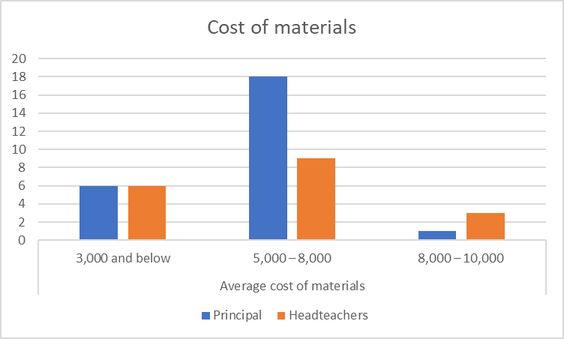
Figure 7: Cost of learning materials by Head teachers and Principals
Source

4.2.3 Cost of acquiring materials for learners
A further corroboration done on the cost of acquiring materials by the learners noted a similar trend. More than half of the learners argued that the materials were expensive with an additional third of them noting that the materials were very expensive.

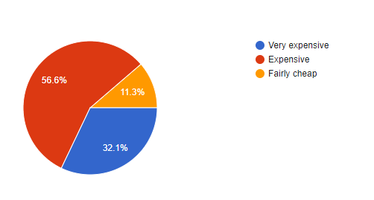
Figure 8: Cost of learning materials by learners
Source

4.3 Effect of Parents finances on school Access
Evidence from the study noted that finance had little effect on school accessibility. The implication here is that regardless of the financial position of the parents access to school is somewhat guaranteed. Perhaps this could be argued from the fact that the Government has applauded free primary school education and compulsory transition to secondary school. The advent of FPE policy as constituted under the ministry ofe education witnessed mass enrolments in public schools. Similarly, beginning last year, the Government had commissioned the Ministry of interior to make sure that all children who completed primary school are enrolled to secondary. Although this is the position by most of the headteachers and principals as presented in the illustration below, upon access (enrolment in school), parents may be called on to provide for some levies, materials.
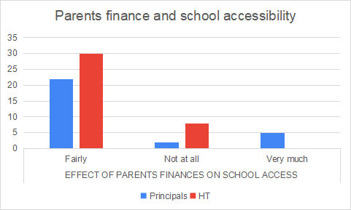
Figure 9: Effect of Parents finances on school Access
Source

4.4 Parents’ interest in their children’s learning
Discussions from the study painted a wanting picture on the interest of parents in the education of their children. As presented in the illustration both the headteachers and principals were in agreement on the low interest by the parents in the education of their children. There were however some efforts in providing learning accessories whilst visiting learners in the school was least practiced by parents, as reported by the principals and headteachers.

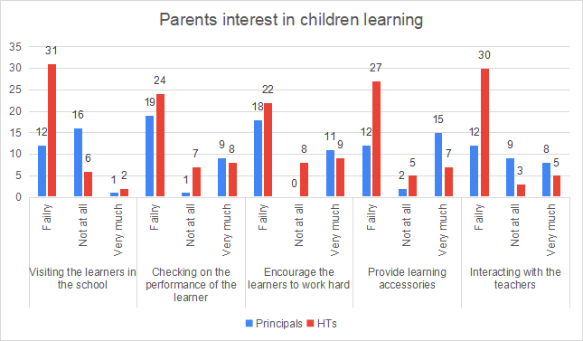Figure 10: Parents’ Interest in their Children Learning
Source

4.5 Influence of School distance on Transition
Both the headteachers and principals were in agreement that distance to and form school has a big influence on learner’s transition. Leaners tracking looking distances as witnessed in some cases, where a learner would do an average of 5 kilometers in a day, are likely to get tired, dose in class, hate school and develop truancy which automatically develops to drop out, if unchecked.
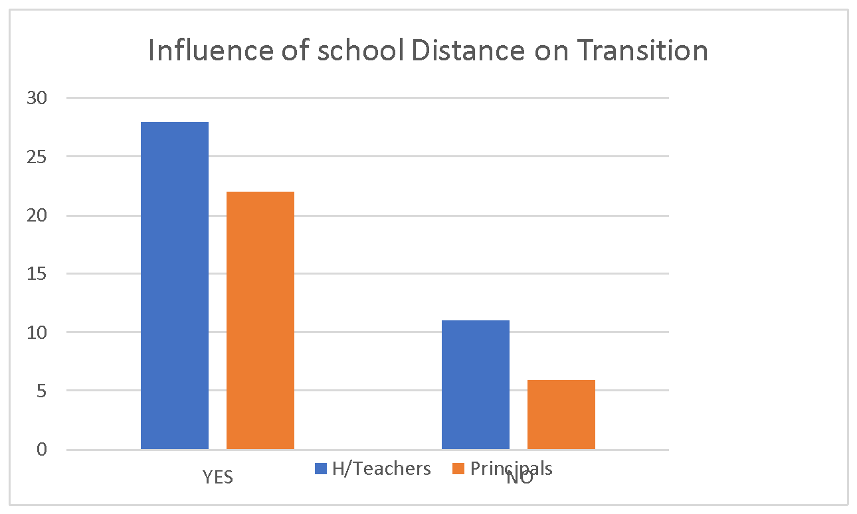
Figure 11: Influence of school distance on Transition
Source

4.5 Factors affecting learning and Transition
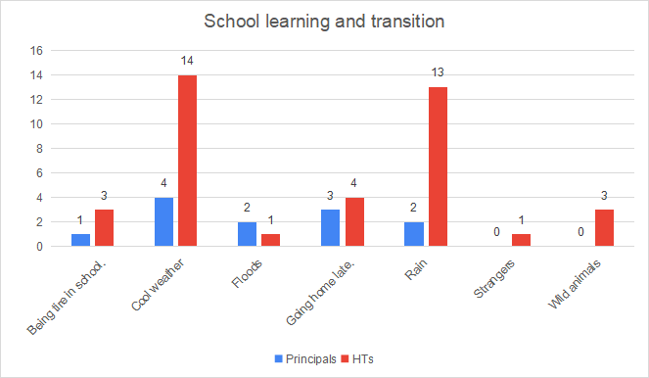
Figure 12: Factors affecting learning and transition
Source
Evidence from the study noted that thus learners track some long distances which expose them to adversities including being rained bad weather, wild animals and strangers who take may undue advantage of their innocence and naivety, subjecting them to possible harm and exploitation. Learners going through this experience usually get tired of school, return home late most of the times and are highly prone to drop out, non- transition.

4.6 Mode of earning and effect on Education
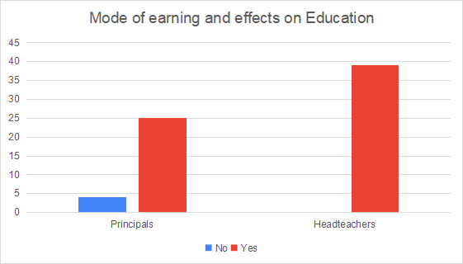
Figure 13: Mode of earning and effect on Education
Source
Asked whether the mode of earning of the parents has any effect of the education of their children, both the head teachers and principals were in agreement that it does affect. Parents in the area of study largely survive on nomadic livestock husbandlry which is susceptible to bad weather especially considering the long dry spell that has been witnessed regionally. Other modes of earning include petty businesses, boda boda riding and casual work at flower farms and the EPZs in the area. These forms are not only sustainable but do not remunerate the parents enough to support education of their children.

4.7 Parents ability to pay school fees
Evidence form the research showed some sense of struggle by parents to pay for their children’s’ school fees. Most of the principals were of the opinion that majority of the parents were able to pay the school fees perhaps also based on the fewer number of children they would send home for school fees. However, the head teachers brought up the issue as a major concern noting that it is a common occurrence.
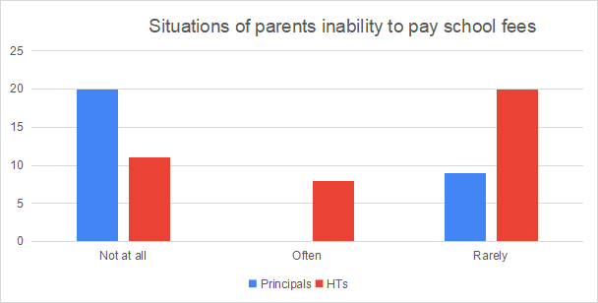
Figure 14: Situations of parents; inability to pay school fees
Source

4.8 Culture and Effect on Learning
The community of study is deeply cultured, traditional ceremonies and festivals are common. These are often matched with practices such as female genital mutilation, early and childhood marriages which further exacerbate the plight of the girl child. These practices largely affect the education and transition of children; as children take time away to attend to the cultural activities, among them never return to school\.Those who get married or pregnancy are rarely rescued and efforts on school re-entry are minimal in the area of study.
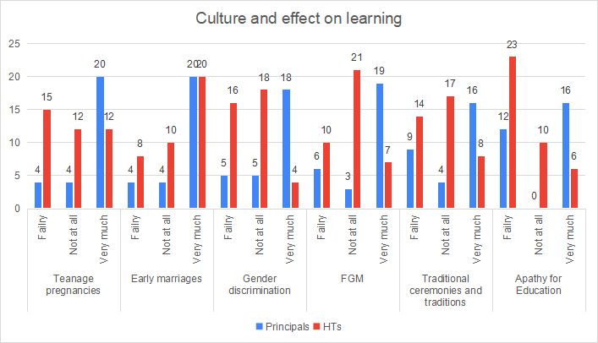
Figure 15: Culture and Effect on Learning
Source:?

4.9 Use of peer role models
Peer role models have been proven to be very influential in many matters and this of education and transition is indifferent. The community under study need to invest on role-modelling as a way to encourage other learners to seek education and transcend to higher levels. The headteacher and principals report this practice as a rare one despite the merits it can accrue on a community.
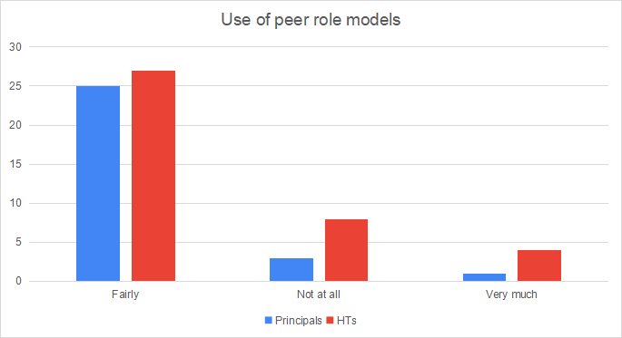
Figure 16: Use of peer role models

CHAPTER FIVE

SUMMARY, CONCLUSION AND RECOMMENDATIONS

5.0 Introduction

This chapter presents a summary of the key findings and conclusion. A set of recommendations are also provided based on the views of the respondents on how to address the gaps identified in the study. The recommendations are also guided by the literature reviewed leveraging authorities on the subject under study. While the researcher has made efforts to as much as possible provide suggestions that may improve on the situation, his views may not be exhaustive and thus public opinions on how best the gaps sighted in the area of study are always encouraged.

5.1 Summary of Findings
In consideration of the literature reviewed on the study subject and findings from the study based on information and comments provided by the respondents the following were key:
5.1.1 Availability of teaching and learning Materials
There was a notable gap on the availability of teaching and learning Materials in the schools under study. Although some of the basic materials such as chalkboard were the most available, important resources such as reference books, teachers guides were lacking. A further comparison between the status of the materials in primary and secondary schools noted the latter to be the most affected. Additionally the non-provision of these materials by the institutions as well as the huge cost of acquiring them was evident. Views of learners on the subject further affirmed the high costs of acquiring the materials.
5.1.2 Financial ability of parents and access of school by their Children
Poverty was established to greatly influence school access and transition of learners in the area of study. Coming from predominantly livestock keeping communities, learners in the study area rely heavily on their parents’ proceeds from the animals. This being the main source of livelihood has however been greatly affected by the climatic conditions as well as the COVID pandemic. For instance, farmers who sell out their animals to butcheries and eateries including night joints and recreational areas have had their business drop tremendously cause of the government COVID protocols (inhibiting free associations) and the curfew limiting the time such business would remain open. The survey further established that there were little chances of getting support from the community with school levies, related expenses. This could partly because the community is homogenous in their financial capabilities. Additionally, these leaners are often pulled out of class (and my eventually drop) as they are required to work, to supplement family income.
5.1.3 Parents and guardians interest on the learner’s performance
Parents and guardians interest on the education and academic performance of their children was noted to be wanting. Asked whether the parents visit the learners in the school checking on their performance, encourage them to work hard, provide them with learning accessories or interacting with the teachers, the respondents noted that very few parents do any of the said. Needless to say, the success of learners being a combined effort between the teacher, the parent and the learner themselves, this missing link (of parents’ interest in participation of their children’s’ education) could be a motivator to not only poor academic performance but ultimate non transition of the learners.
5.1.4 Distance to and from school; majority of the schools in the study area are day schools with very few, Boarding and Mixed day and boarding schools. Additionally, they are distant from the residences of most of the learners as they are mostly established in open and large grounds away from the human settlements. This thus requires the pupils to track some long distances which further expose them to adversities including being rained bad weather, wild animals and strangers who take may undue advantage of their innocence and naivety, subjecting them to possible harm and exploitation. Learners going through this experience usually get tired of school, return home late most of the times and are highly prone to drop out, non- transition.
5.1.5 Cultural factors and their effect on Education/transition:
Teenage pregnancies, early marriages, gender discrimination, FGM, traditional ceremonies and traditions apathy for education were seen to greatly affect education and transition. The fact that the community of study is deeply rooted in culture further aggravated the situation.
Use of peer role models: As a way to encourage other leaners, peers who have excelled academically are used to motivate others. This is practice that is not common in the community under study may inhibit positive encouragement on learning and thus transition.

5.2 Conclusion
In conclusion, the study was able to establish the challenges of school transition as set in the sample size and study area. The objectives of the study as well as the questions set therein have been to a large extent been addressed by the study.

5.3 Recommendations
To address the challenges sighted in the study and in cognizant to the suggestions provided by the respondents, the study recommends the following
5.3.1 Community sensitization on Education. There is need for community sensitization on education and specifically the role of parents in educating their children. Whilst the researcher acknowledges the various gaps that may inhibit learning and transition, he feels that community attitude especially that of parents on the education of their children is paramount and comes out as priority one.
5.1.2 Provision of Teaching and Learning Materials: As sighted to be one big challenge to teachers as well as learners, the issue around teaching and learning materials cannot be over emphasized. The researcher calls on relevant parties to consider this a clarion call and pay the needed contribution to improve on the situation. Primarily, the researcher calls on the following:
Ministry of Education- ensure adequate fund allocation to schools to enable provision of materials
School Management Boards: foster alternative resource mobilization beyond depending on government and parents to enhance teaching/ learning materials provision
Parents and General Community: Consider provision of materials to their children as their innate responsibility regardless of whether government or other parties shall or not provide same.
Partners and donor community: consider supplementing Government and parents’ efforts in provision of learning materials and support transition of learners.
Collaboration from relevant sector players: the challenges of transition as sighted in the research are far beyond the capacity of any one party to address single handedly. Transition is an influence of many factors including resources, culture and even attitude. These will be addressed well by different sector players in both the public and NGO sector. The researcher thus recommends the need to take a Multi-disciplinary approach to addressing transition.
To conclude, the survey was able to establish the challenges affecting Education transition in the area of study. The lack of materials, parents’ aloofness in the education of their children, lack of role models are some of the drawback to transition whose need to address is now rather than later. As a human and constitutional right, every individual (and community by extension) deserves a quality education, which of course incorporates quality transition and the area under study is not an exception.

5.4 Suggestions for Further Research
1. Survey to establish the rate of transition in the study area
2. The role of the study area County Government on Education and Transition
3. Comparative analysis of transition by boys and girls in the study area.
4. Effect of CBC on Government’s attention to 8-4-4 system of Education.

REFERENCES

Emore, C. (2005). Causes of students’ lateness to school. In Ivwie, L.G.A. of Delta state. Abraka, Nigeria.
EFA Global Monitoring Report (1987) Reaching the Marginalized: Education for All, Oxford University Press, Oxford, UK
Famuel, P. (2010). The benefits of education. London: Oxford University Press.
Mugenda, N.O.&Mugenda, A,G.(2003). Research Methods: Quantitative and qualitative approaches.Nairobi:Acts press
Obayan, P. T. (2003). Realizing Nigerian millennium education dream. In O. Bamiasaiye, Nwazuoke and Okediran (Eds.). Ibadan: The UBE.
Kituyi, M. (1990). Becoming Kenyans, Socio-economic Transformation of the Pastoral Maasai. Nairobi, ACTS Press
Ochieng’, W. (1975). An outline History of The Rift Valley of Kenya up to A.D. 1900. Nairobi, East Africa Literature Bureau
Government of Kenya (2009).Trends in the growth of enrolment in primary schools at the advent of free primary education Government printer.
Government of Kenya (2010). Government Appropriators bill 2010. Government Printer. Nairobi: Kenya.
Government of Kenya, (1999 – 2015). National Poverty Eradication Plan. Nairobi: Government Printer
UNESCO, (1996). Education for all: Achieving the Goal. A Working Document. .Paris: UNESCO
United Nations Educational, Scientific and Cultural Organization (UNESCO) (2008) Positioning secondary-school education in developing countries: expansion and curriculum. Paris:
Miguel, E., and Gugerty, M.K., (2004) ―Ethnic Diversity, Social Sanctions and Public Goods in Kenya,‖ Journal of Public Economics, Forthcoming
Morisson T R, (1997), The Children of Modernizations: Adolescence and the development of Mauritius, Bahadoor Printing, Port Louis.
Orodho A.J. (2005). Research Methods Kenyatta University, Institute of Open Learning. Nairobi: Masola Publishers.
Onyango, G. A. (2001). Competencies Needed by Secondary School Head teachers and Implications on Pre-service Education. Unpublished PhD Thesis. Nairobi: Kenyatta University.
Parsuramen, A, (1994). Our Children Our Future Our Hope, Kin Keong Printing Co. Pte Ltd, Singapore

APPENDICS
APPENDIC- A: Questionnaires in the Survey (for Teachers/Students/stake Holders etc.)

APPENDIC -B:
QUESTIONNAIRE FOR THE SECONDARY SCHOOL PRINCIPALS
The purpose of this questionnaire is to gather information about your views as regards factors contributing to transition rates from primary school level to secondary school level in Isinya sub county, Kajiado County. Your response will be highly appreciated. Please do not indicate the name of the school.
Instructions
Please indicate the correct option to the best of your ability by way of ticking in the space provided. For questions that require your input in terms of opinion, kindly fill in the answers in the spaces provided. Kindly make a point of responding to all items.
Background Information
1. a) Gender: Male [ ] Female [ ]
b) Age: 20-30 years [ ] 31 – 40 years [ ]
Over 50 years [ ]
2. What is your highest academic qualification?
DIP [ ] BED [ ] MED [ ]
Any other (specify)____________________________________

3. Teaching experience:
0 -5 years [ ] 6 - 10years [ ]
11-20 years [ ] over 20 years [ ]
4. How long have you worked at your current station?
1 – 5 years [ ] 6 – 10 years [ ]
- – 20years [ ] over 20years [ ]
Part A: Provision of teaching and learning materials.
1. Which of the following teaching and learning materials are used in your school?
1 Yes 2 No
Teaching materials learning materials
Chalk board/chalk 1{ } 2{ } Course books 1{ } 2{ }
White board/mark pen 1{ } 2{ } Supplementary books 1{ } 2 {
Charts 1{ } 2{ } Pens 1 { } 2 { }
Black board ruler 1{ } 2{ } Pencils 1{ } 2 { }
TLD 1{ } 2{ } Rulers 1{ } 2{ }
Teachers guide books 1{ } 2{ } Mathematics set 1{ } 2 { }
Reference books 1{ } 2{ }

1. Does your institution provide the teaching and learning materials to the students?
1. Yes[ ] 2 No{ }
2. If no what is the average cost of acquiring the teaching and learning materials by a student per year
1. 3,000 and below [ ]
2. 5,000 – 8,000 [ ]
3.8,000 – 10,000 [ ]
Any other _________________________________________________
3. Does it affect the number of learners from your institution to access secondary school education going by the financial ability of the parent?
Very much [ ] Fairly [ ] Not at all [ ]
4. Do the parents and guardians in your school have keen interest on the learner’s performance?
Very much [ ] Fairly [ ] Not at all [ ]
5. Do they engage in any of the following activities?
1) Not at all 2) fairly 3) very much
Visiting the learners in the school 1 { } 2 { } 3 { }
Checking on the performance of the learner 1 { } 2 { } 3 { }
Encourage the learners to work hard 1 { } 2 { } 3 { }
Provide learning accessories 1 { } 2 { } 3 { }
Interacting with the teachers 1 { } 2 { } 3 { }
6. Do the factors listed above affect the rate of progress from primary school to secondary school level? Please explain ____________________
Yes [ ]
No [ ]
6. Please explain the reasons for your answer_______________________
___________________________________________________________
Part B: Distance to and from school.
What type is your school?
1. Day school { }
2. Boarding school { }
3. Mixed day and boarding school{ }
If day and mixed day and boarding school, does the fooling activities affect your students?
1 Not likely 2 Likely 3 Most likely
a} Rain 1{ } 2{ } 3 { }
b} Cool weather 1{ } 2{ } 3 { }
c} Floods 1{ } 2{ } 3 { }
d} Wild animals 1{ } 2{ } 3 { }
e} Strangers 1{ } 2{ } 3 { }
f} Being tire in school. 1{ } 2{ } 3 { }
g} Going home late. 1{ } 2{ } 3 { }
Part C: Family social-economic status
7. Does your institution enquire about the mode of the parents of the learners in your schools way of earning a living?
Very much [ ]
Fairly [ ]
Not at all [ ]
8.Is there a relationship between their mode of earning a living and their ability to finance their children’s education in secondary school
Yes [ ]
No [ ]
9. What are the reasons for your answer?_____________________________
_________________________________________________________

10. Have you had situations of parents from your school not having the ability to pay for their children’s secondary school education in your school?
Often [ ] Rarely [ ] Not at all [ ]
11. In the events of a parent’s inability to pay for their children secondary school education, have there been any initiative by the community to take care of the same?
Part D: Cultural Factors (culture AND EFFECT ON LEARNING)
13 In your assessment to what extent does any of the following factors hindered the process of learning in your institution?
1. Not at all 2.Fairly 3. Very much
Teenage pregnancies 1{ } 2{ } 3{ }
Early marriages
Gender discrimination 1{ } 2{ } 3{ }
FGM 1{ } 2{ } 3 { }
Traditional ceremonies and traditions 1{ } 2{ } 3{ }
Apathy for education 1{ } 2{ } 3{ }
14 Which of the activities listed above has the most profound effect with regard to transition from primary school to secondary school?_______ ________________
15 Does your institution have a system of engaging old students who have excelled to act as role models for the other learners to excite their passion for academic activities?
Very much [ ] Fairly [ ] Not at all [ ]
16 Has it had any effect on the learner as regards their passion for academics?
To a great extent [ ] To a fair extent [ ] Not at all [ ]
Thanks for your participation.

APPENDIC- C: Minutes of Meetings

APPENDIC -D: Observation Check lists if you have

APPENDIC -E: Regional Administrative Secretary Letter (RAS)
25/ 4/2021
INTRODUCTION LETER

CYRUS S. KOSENCHA
P.O BOX 423, KAJIADO.
TO
THE TSC COUNTY DIRECTOR
KAJIADO COUNTY
P.O.BOX 56-01100
KAJIADO
REF: DATA FROM TEACHERS.
Dear Sir/Madam
I am a postgraduate student at the Lukenya University pursuing a course leading to the award of a master’s degree. As part of fulfillment for the award, I wish to conduct a research on Factors Influencing Transition Rate of Learners from Primary to Secondary Schools in Isinya sub County of Kagiado County. Your school has been identified to participate in the study. I request for your assistance and co-operation to enable the study come up with accurate findings. Be assured that utmost confidentiality will be maintained concerning any information gathered from the institution. Thanks in advance.
Yours in service,
Cyrus S. Kosencha.

Appendix F:
Introduction for research instruments
20/6/2021
Dear Participant,
RE: RESEARCH PROPOSAL
I am a Masters student in Educational Management and Administration at Lukenya University. I wish to carry out collection of data for my research from selected primary and secondary schools in Isinya Sub-County, in Kagiado County. The purpose of this research is to carry out a study Factors Influencing Transition Rate of Learners from Primary to Secondary Schools in Isinya sub County of Kagiado County .The present study is purely academic hence; any data given will be treated with utmost confidence. Code of ethics will be ensured such that names of the respondents will not be included at the end of the study.
I thank you in advance as I look forward to work with you.
Yours faithfully
Cyrus Kosencha

APPENDIC -G: District Administrative Secretary Letter (DAS)

APPENDIC -H
QUESTIONNAIRE FOR LEARNERS
The purpose of this questionnaire is to gather information about your views as regards factors contributing to transition rates from primary school level of education to secondary school level in Isinya sub county, Kagiado county. Your response will be highly appreciated. Please do not indicate your name. Instructions Please tick against the current option and fill in the space with the required information for the questions that require your opinion kindly respond to all THE questions.
Part A: Background Information
1. What is your gender: Male [ ] Female [ ]
2. Kindly indicate your age__________
B: Provision of Teaching and Learning Resources
3. How do you perceive the cost of acquiring the teaching and learning materials eg books, pens, manila papers, supplementary books, calculators etc?
Very expensive [ ]
Expensive [ ]
Fairly cheap [ ]

4. Have you had members of your family or your friend who have failed to proceed to secondary school because of the costs teaching and learning materials?
Often
Rarely [ ]
Not at all [ ]
5. Are you aware of any programmes and initiatives by the school authorities to provide the teaching and learning materials?
Very much [ ]
Fairly [ ]
Not at all [ ]
6. Kindly explain how one can be assisted through secondary school in absence of school fees? ______________________________________________
Part C: Distance to and from school.
Are you
Day scholar { }
Boarder { } (TYPE OF SCHOOL)
7. (a.) If you are a day scholar what distance do you travel to school -----------------kms?
(b.) In your opinion, do you think the distance covered to and fro school has any effect on learning and transition?
Yes{ }
No{ }
8. Does the following factors affect you as you travel to and from school?
1 Not likely 2. Likely 3 Most likely
a} Rain 1{ } 2{ } 3 { }
b} Cool weather 1{ } 2{ } 3 { }
c} Floods 1{ } 2{ } 3 { }
d} Wild animals 1{ } 2{ } 3 { }
e} Strangers 1{ } 2{ } 3 { }
f} Being tire in school. 1{ } 2{ } 3 { }
g} Going home late. 1{ } 2{ } 3 { }

Part D: Family social-Economic factors.
7. How do your parents earn a living?
Animals keepers { }
Employed [ ]
Commercial farming [ ]
Casual workers [ ]
Quarrying [ ]
Any other _______________________________________________
8. Does your parents / guardian pay attention to your academic activities?
Very much [ ]
Fairly [ ]
Not at all [ ]
9. Does the source of the household income affect the ability of the parents to pay the school fees ?
Very much [ ]
Fairly [ ]
Not at all [ ]
10 .Kindly explain how it affects their ability to pay the school fees _________________________________________________________
11. Do you receive encouragement from home for you to study hard and proceed to secondary school?
Often [ ]
Rarely [ ]
Not at all [ ]
12. Do the presence / lack of encouragement affect you in any way? Please explain__________________________________________________ _________________________________________________________
Part E: Cultural Factors
13.Are there any members of your family or your friend who have not gone to secondary school because of any of the following factors?
1. Not at all
2. Fairly
3. Very much
Teenage pregnancies 1{ } 2{ } 3{ }
FGM 1{ } 2{ } 3 { }
Traditional ceremonies and traditions 1{ } 2{ } 3{ }
Apathy for education 1{ } 2{ } 3{ }
Gender discrimination 1{ } 2{ } 3{ }
Getting short – term employment 1{ } 2{ } 3{ }
Any other _________________________________________________
14. Are there models in your family and community who you can admire and emulate on the basis of their academic achievements?
Yes [ ]
No [ ]

15. Do they encourage you to study and achieve academic success?
Yes [ ]
No [ ]
Thank you for your corporation

Appendix I: Time Frame
Duration | Activities
July – September 2020 | Preparing pre-proposal
October 2020 | Writing chapter one of proposal  Doing corrections
November 2020 | Writing chapter two  Doing corrections
December 2020 | Writing chapter three  Doing corrections
January 2021 | First defense presentation  Correction on research proposal
March 2021 | Second defense  Correction on research proposal
May – July 2021 | Data collection and analysis  Writing chapter four and five
August 2021 | Seminar presentation  Correction on project
September 2021 | Oral examination presentations
October 2021 | Corrections on final draft
November 2021 | Printing of final document
December 2021 | Graduation

Appendix J: Budget
The following is the approximate budget that will be required to carry out the research.
Activities | Quantity | Unit cost | Total
Literature review and collection of secondary data | Approx. 20 trips to library | 1,000 | 20,000
Internet cost | Monthly for 24 months | 1,000 | 24,000
Typesetting and printing (proposal) | 125 pages | 50 | 6,250
Photocopying and binding proposal | 125 pages × 18 copies | 3 | 8,010
Piloting instruments | 20pgs × 12 copies | 720 | 12,000
Transport - piloting | 6 schools | 1,500 | 4,500
Research Permit from NACOSTI | 1 | 2,000 | 2,000
Data collection – Transport, accommodation and subsistence | 15 days | 3,000 | 45,000
Typing, printing and photocopying research instruments | 20pgs × 260 | 3 | 15,600
Photocopying of research report | 125pgs × 24 | 3 | 9,000
Binding copies of research report | 5 | 1,500 | 7,500
Printing final copies and binding | 5 copies | 2,000 | 10,000
Submission of final hardbound copies | Fare |  | 2,000
Total |  |  | 165,860

